**Assignment 1**

|  |  |
| --- | --- |
| **Date** | 27 September 2022 |
| **Team ID** | PNT2022TMID47816 |
| **Project Name** | Inventory Management System |
| **Batch number** | B8-2A4E |

**1.Create registration page in html with username, email and phone number and by using POST method display it in next html page.**

# Registration.html

<html> <head>

<style> body

{

background-color:pink; fontfamily:Times New Roman; font-

size:25px; font-weight:bold;

}

h1

{

background-color:red; align:center; color:White; fontfamily:Times New Roman;

opacity:0.4;

}

input

{

width:50%; padding:12px 20px; margin:8px 0; display:inlineblock; border:1px solid #ccc; border-radius:4px; boxsizing:border-box; background-color:violet;

}

</style>

<body>

<h1>REGISTRATION FORM</h1>

<form action="Display.php" method="post">

Enter Username:<br><input type="text" name="uname"/><br><br>

Enter Email Id:<br><input type="email" name="mail"/><br><br>

Enter Phone number:<br><input type="number" name="ph"/><br><br>

<input type="submit" name="Next"/>

</form>

</body>

</html>

# Display.php

<html> <style> body

{

background-color:violet; font-family:Times

New Roman; font-size:25px;

}

p

{

font-weight:bold; color:Blue;

}

</style>

<body>

<marquee>Welcome <?php echo $_POST["uname"]; ?><br></marquee>

<h1>USER DETAILS:</h1>

<p>USER NAME:</p><?php echo $_POST["uname"]; ?><br>

<p>EMAIL ID:</p><?php echo $_POST["mail"]; ?><br>

<p>PHONE NUMBER:</p><?php echo $_POST["ph"]; ?><br>

</body>

</html>

**Output:**

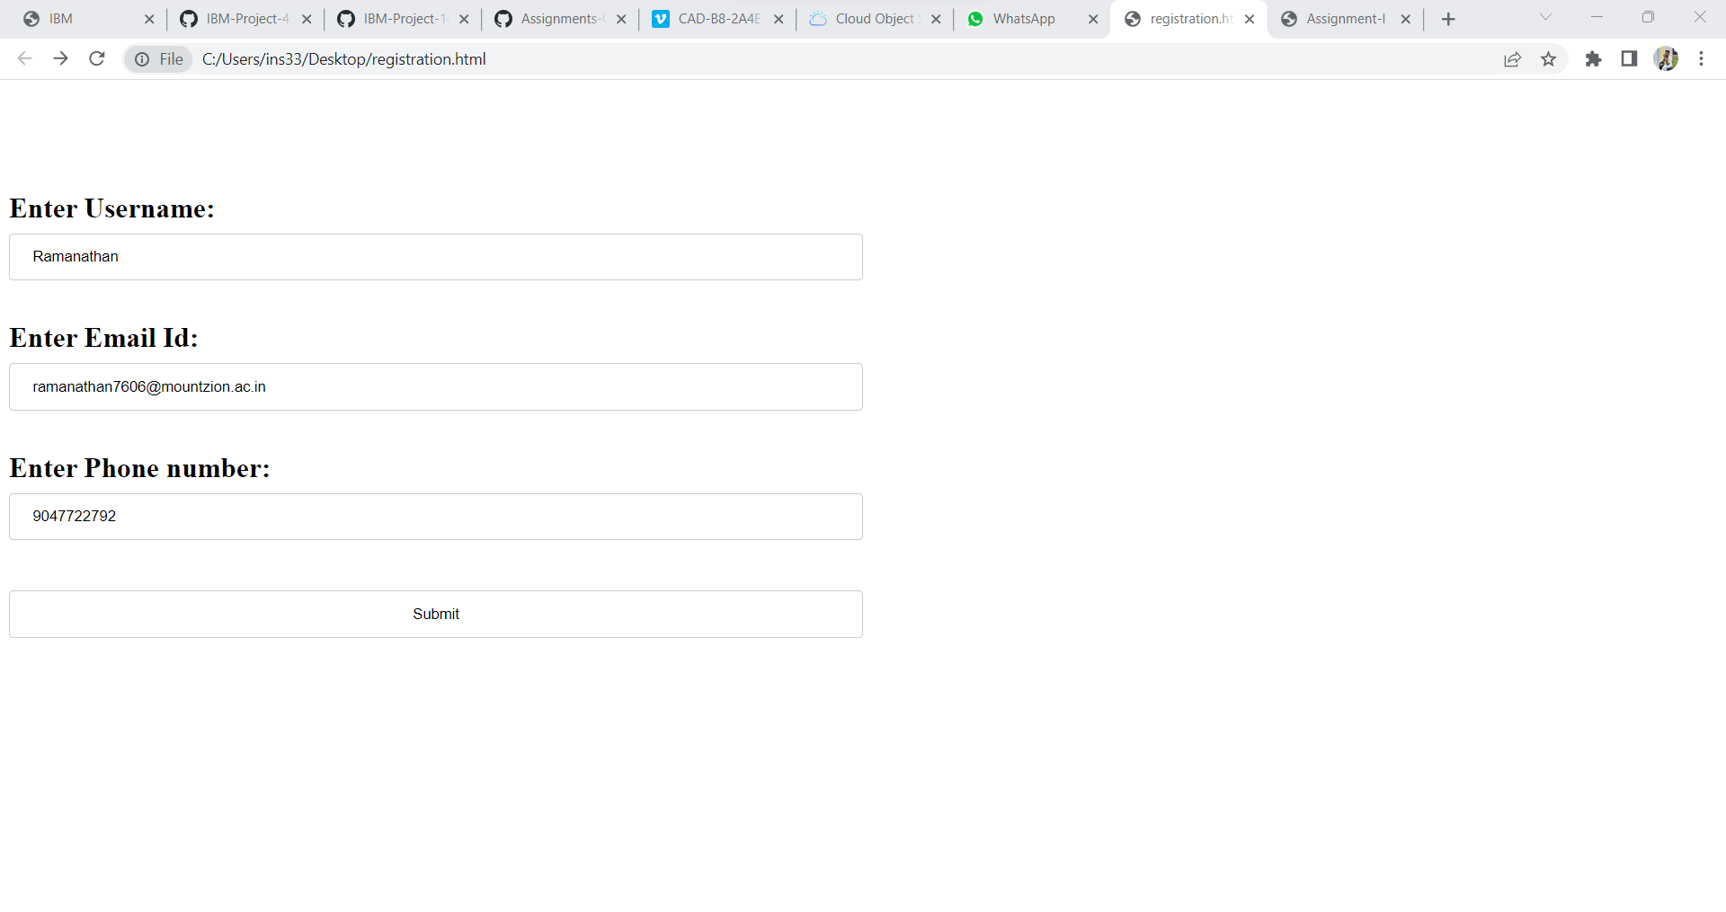

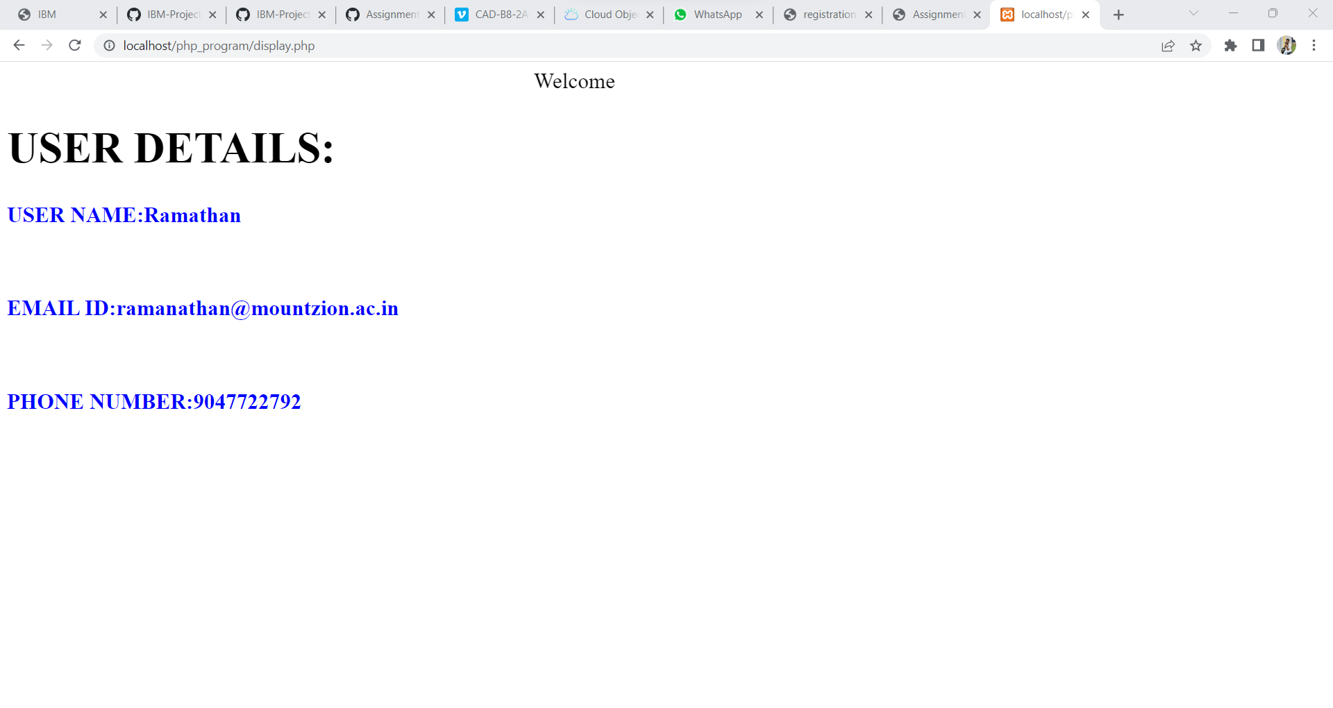

**2.Develop a flask program which should contain at least 5 packages used from pypi.org. app.py**

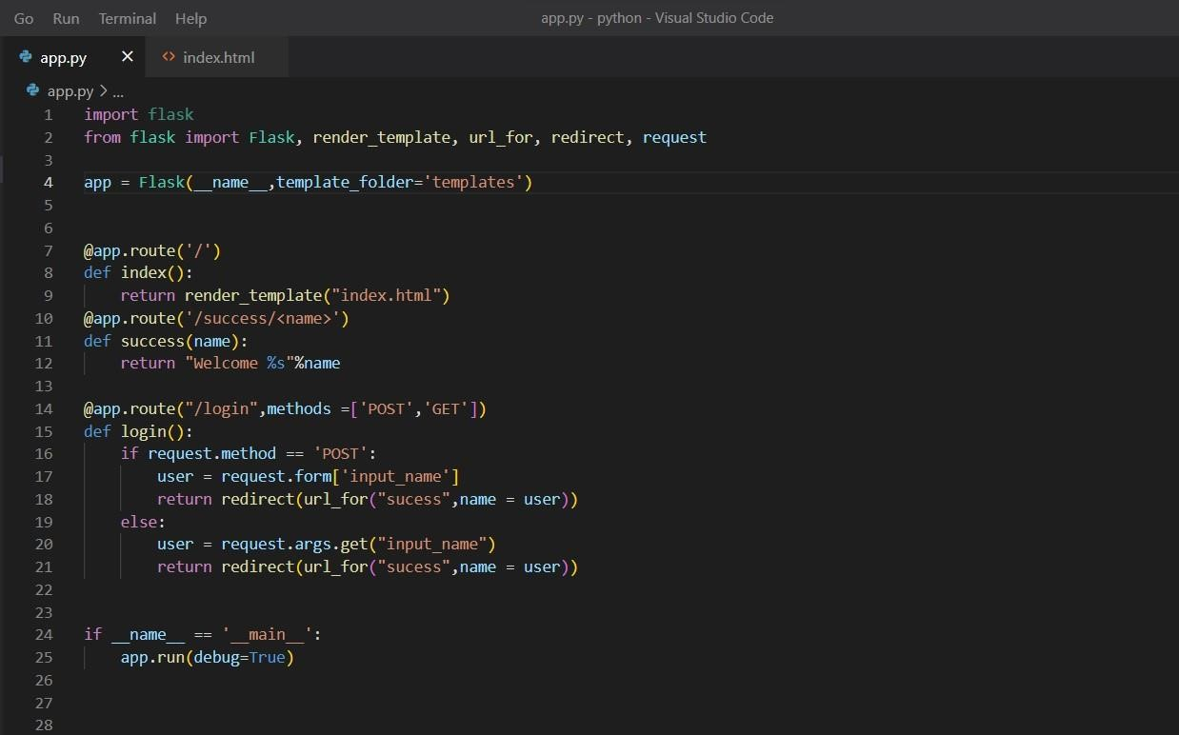

# Index.html

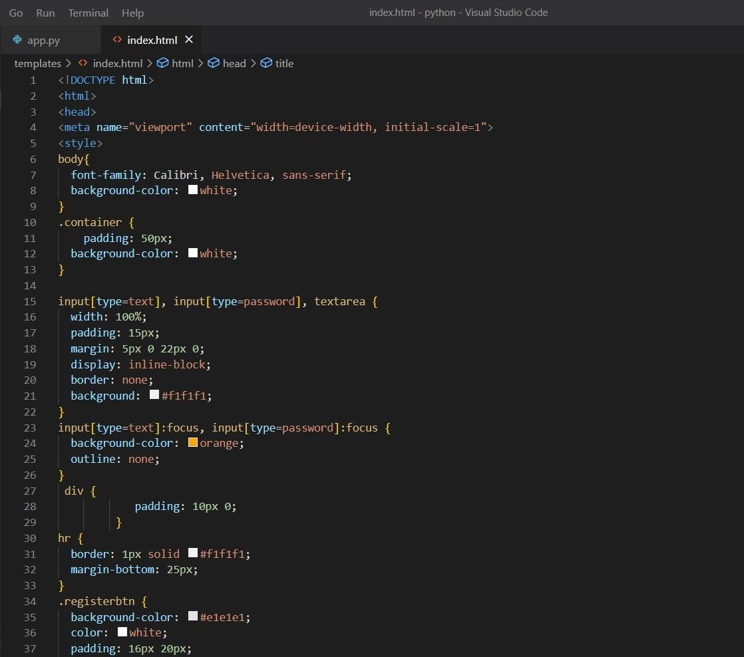

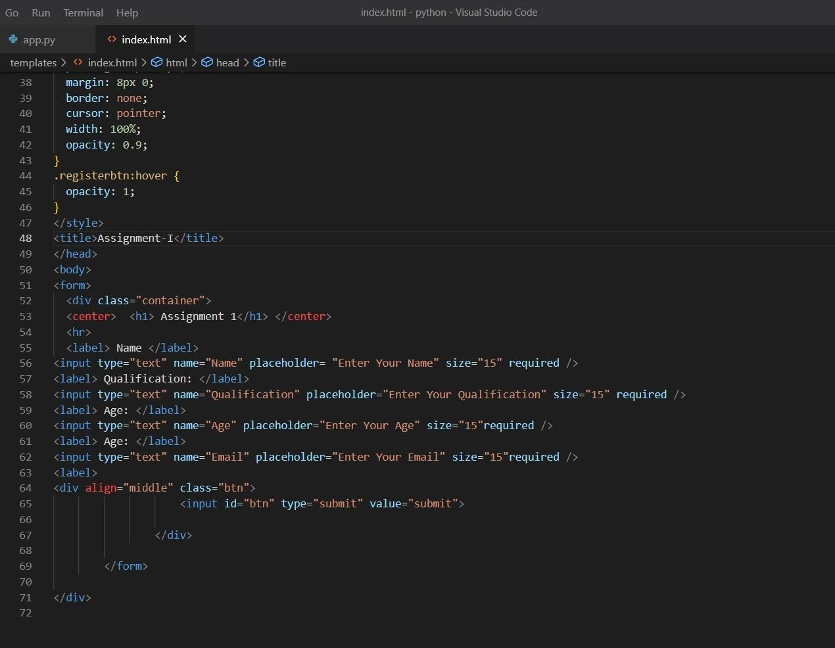

**Output:**

